CSA1503-Cloud computing and big data analytics

Experiment : Payroll management
input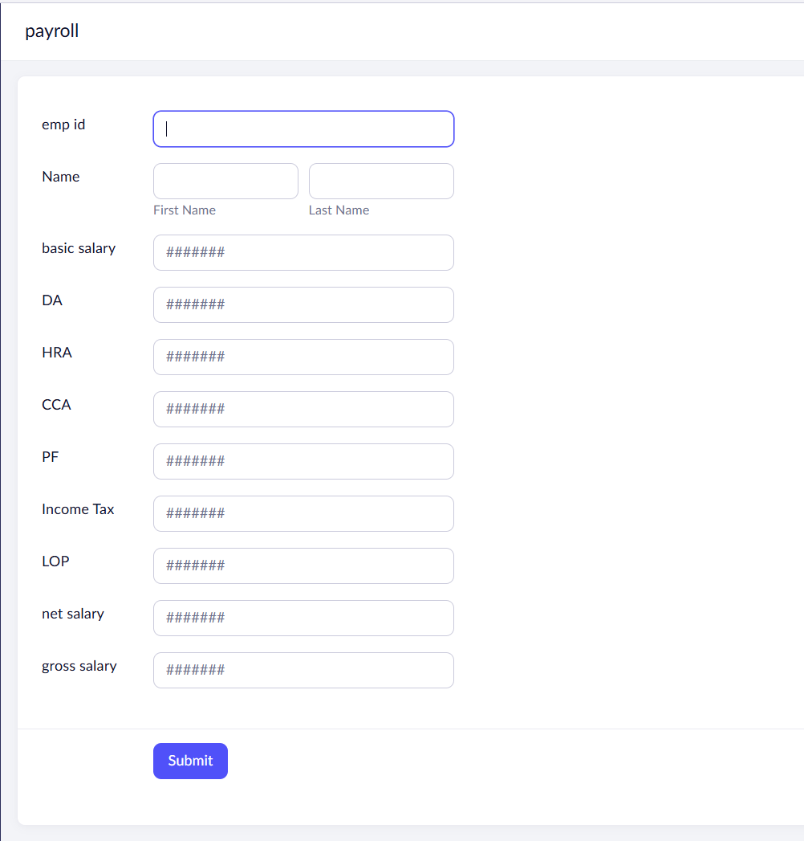

Output
